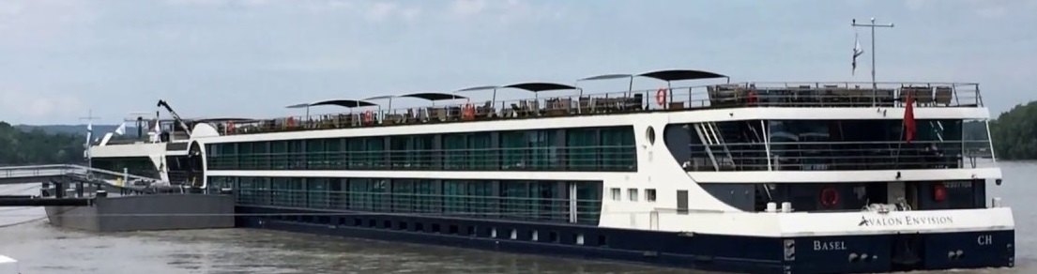

GIFTS FROM ABOVE TRAVEL PRESENTS:
“CRUISE THE DANUBE WITH US”
APRIL 3 - 11th, 2024
ON THE AVALON WATERWAYS ENVISION
WESTBOUND ROUTE – BUDAPEST TO VILSHOFEN
This is your opportunity to sail THROUGH Europe – not simply TO Europe!

The cost for this inclusive package: $3549 per person (Based upon a Category E, deck one, outside stateroom with window and double occupancy --and we will deduct an additional $100 pp if deposit is made by April 30, 2023)

A $500 deposit per person, made payable to ‘Gifts From Above’, is due with application.
Final payments are due: DEC 1, 2023. (we do not accept credit cards – payment must be in the form of check or bank transfer – contact us for details)

This 9-NIGHT//8-DAY cruise tour out of fabulous Budapest will visit Hungary, Slovakia, Austria, and Germany and has been packaged to include the following:
- Round trip air from ORD, NYC or MIAMI (*see #1 exceptions/notices below)
- Greeting at Budapest Airport and Transportation to the cruise ship.
- Visits to the following ports of call: Bratislava, Vienna, Wachau Valley, Durnstein, Melk, Ybbs, Linz, Passau and Vilshofen.
- 7 Night accommodations in a Category E, deck one, outside stateroom with window on AVALON ENVISION – launched in 2018 this elegant, contemporary ship has all the latest innovations and features, but due to its maximum guest size of only 166 passengers, feels both intimate and welcoming. (*see # 2 & 3 exceptions/notices below)
- Full board (breakfast, lunch, and four-course dinners) – offering exceptional cuisine, including Avalon’s Fresh Menu options and versatile Flex Dining venues including the casual Panorama Bistro, al fresco Sky Grill or the elegant Dining Room
- AVALON’S drink package featuring soft drinks, premium coffee, local wines, beers and spirts.
- Club Lounge which provides 24-hour self-serve beverage station with complimentary cappuccinos, lattes, tea, hot chocolate as well as treats throughout the day.
- State-of-the-art Fitness Center
- Adventure Center for bikes and active gear such as Nordic walking sticks and maps plus onboard umbrellas (no need to pack one).
- English-speaking crew, staff, and a professional Cruise Director.
- An Avalon Adventure Host to assist with active excursions, yoga, and workouts.
- Multiple excursion activity levels at every port including Gentle Walker, Classic, Active or Discovery options and audio connections so every word spoken by guides can be heard.
- SKY DECK – with whirlpool, shade awnings, game area and premium lounges. (relax in the hot tub and enjoy a drink while soaking up the view as we cruise the Danube).
- Shipboard and Evening entertainment – including live piano and local talent.
- All tips for onboard services (*****see #4 exception below)
- All port charges and fuel charges
- Complimentary Wi-Fi access
- Return to airport post-cruise transfers for our return flights home from MUNICH

EXCEPTIONS AND EXCLUSIONS:
- Coach Airfare is included in our quote. (Seat upgrades as well as other nationwide departures are available upon request – passengers pay only the difference – quotes will be given).
- Each Stateroom category is available until sold out; prices are based upon double occupancy.
- The inclusive price quoted is for CATEGORY E (outside stateroom deck 1) Upgrades to CATEGORY D (outside staterooms decks 1) are available for an additional US $199.00 per person or CATEGORY A (Panorama suite with balcony, deck 2). US $1399.00 pp.
- WHILE ALL TIPS AND GRATUITIES ARE INCLUDED FOR ALL SERVICES ON THE CRUISE SHIP – OUR CLIENTS NEED TO BE AWARE THAT OUR CRUISE DIRECTOR & GUIDES AT EVERY SITE ANTICIPATE GRATUITIES. TIPS WILL BE ENTIRELY AT YOUR DISCRETION. [General recommendations are 3-4 Euro per person for a half day tour and 4–7 Euro for a full day tour.
- COVID TESTS & VACCINES – if required, will be the individual’s responsibility.

Benefits of group River Cruise travel through a country:
- Our extensive panorama of sites and excellent guides will bring the history of each country and every town alive.
- You unpack and pack only once.
- The official shipboard language is English; there’s always someone on hand to help and give guidance.
- The food is exceptional -- you won’t have to worry about finding good, reasonable restaurants, and you’ll still have the flexibility to dine alone or with friends.
- Breakfast, lunch, and dinner plus plenty of snacks are included on the ship.
- There will be independent time. You’ll have fun exploring, shopping, or relaxing on your own or with your new friends. Lots of options – plenty of choices to suit your mood.
- No hidden extras. You won’t have to deal with the inconvenience and extra expense of handing out tips to porters and chambermaids throughout your stay.
- We will have a professional tour director; licensed guides and professional drivers. You can completely relax, knowing that an experienced escort is taking care of all the details and reconfirming every arrangement for your comfort and enjoyment.
- Travel by cruise ship to our destinations is safe and secure. Embarkation security is comparable to the high standards of airlines. While many European cities currently have ‘travel advisories’ in effect, there are no longer advisories for the countries we will visit.

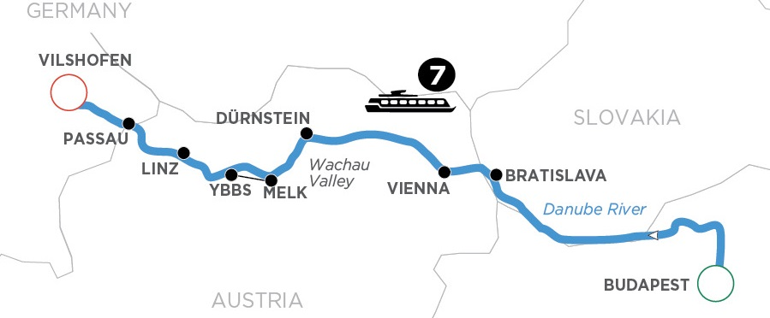

OUR 9-DAY ITINERARY AT A GLANCE
APRIL 3, Wed. -- depart USA for on overnight flight to Budapest, Hungary
APRIL 4, Thurs. – arrive Budapest –– we are met at airport/transferred to the ship. You are free to explore or rest – your choice. There will be an onboard welcome reception,
APRIL 5, Fri. – Full day in Budapest – choices of tours, hiking, biking, or exploring on your own. Come evening, we set sail.
APRIL 6, Sat. – Bratislava – choices for guided sightseeing include Bratislava Castle, St. Martin’s Cathedral or city tours.
APRIL 7, Sun. – Vienna – lots of choices and plenty of free time to explore.
APRIL 8, Mon. – Durnstein – Wachau Valley – Ybbs – so many options: walk or hike to the ruins of the castle; visit the Benedictine Abbey in Melk; Artstetten Castle in Ybbs.
APRIL 9, Tues. – Linz – Hauptplatz, Trinity Column – shopping and free time.
APRIL 10, Wed. – Passau – scenic cruising and sightseeing options.
APRIL 11, Thurs. – Vilshofen – disembark -- transfer to airport for flight home.

------------------------------------------------------------------------------------------------------------------

OUR REFUND POLICY – PLEASE NOTE: Travel insurance with ‘cancel for any reason’ clause is highly recommended. We will send a quote from Travel Guard as each booking is made.
Gifts From Above will issue a full refund of all deposits within a 30-day period of new applications --
Due to supplier regulations, a $250 administrative fee will be deducted from all refunds requested after 30 days.
We will purchase group airline seats. Airline seats are nonrefundable/ nontransferable and are not exchangeable.
60 days prior to departure only a 25% refund will apply. Cancellations made between 59 and 40 days prior to travel will receive only a 10% refund.
Cancellations made 39 days or less before travel date are ineligible for any refunds.
– ANY REQUESTS FOR CANCELLATIONS MUST BE MADE IN WRITING TO GIFTS FROM ABOVE. THE POST MARK ON THE ENVELOPE (OR YOUR E-MAIL) WILL SERVE AS DATE OF OFFICIAL NOTICE OF INTENT TO CANCEL.
PLEASE NOTE -- AIRLINE TICKETS AND SEAT ASSIGNMENTS - We negotiate special rates with major carriers and air arrangements are subject to certain restrictions on change/or cancellation, eligibility and seat assignments. Group seating policy is different for each airline. Gifts From Above Travel is not in control of seat assignments. Seats are subject to airline discretion and may change without notice. We do everything possible to confirm seats whenever available. Some airlines and/or fare types do not allow for pre-seating and require this be done at airport check-in only. Even when seats are originally pre-assigned, they are not guaranteed and can be modified by the airline due to equipment changes. Bulkhead and exit row seats cannot be requested or pre-assigned ahead of time. Bulkhead seats are given to the passengers traveling with infants and for those with disability. Exit row seats are held for assignment at airport check in only, as passengers wishing to sit in these seats must be physically capable of carrying out the associated responsibilities. The airline agent must see a passenger’s physical condition before assigning them an exit row seat. On most routes, these seats can be purchased for a fee on arrival at the airport.
At the time of booking our flights we will update all travelers on seating regulations.
Gifts From Above is not responsible for flights that are occasionally overbooked, delayed or cancelled by the airlines. All fares and schedules are subject to change without notice.
PLEASE NOTE – RESPONSIBILITY / DISCLAIMER STATEMENT - Gifts From Above Travel acts only as an agent for the various independent suppliers that provide hotel accommodations, transportation, sightseeing, activities, or other services connected with this tour. Such services are subject to the terms and conditions of those suppliers. Gifts From Above Travel and their respective employees, agents, representatives, and assigns accept no liability whatsoever for any injury, damage, loss, accident, delay, or any other incident which may be caused by negligence, defect, default of any company or person in performing these services. Responsibility is not accepted for losses, injury, damages or expenses of any kind due to sickness, weather, strikes, hostilities, wars, terrorist acts, acts of nature, local laws or other such causes. All services and accommodations are subject to the laws and regulations of the country in which they are provided. Gifts From Above Travel is not responsible for any baggage or personal effects of any individual participating in the tours / trips arranged by Gifts From Above Travel. Individual travelers are responsible for purchasing a travel insurance policy, if desired, that will cover some of the expenses associated with the loss of luggage or personal effects.
PLEASE NOTE – PHOTO/VIDEO RELEASE - I hereby consent to and authorize the use and reproduction by Gifts From Above of any and all photography and/or videography that has been taken of me this trip for any purpose, without compensation to me. All digital image and/or video files are wholly owned by Gifts From Above, who reserves the right to use these images and/or video for publication on their website, Facebook page, and/or LinkedIn.
ROBERTA KLEIN
GIFTS FROM ABOVE
1535 MEMORIAL HIGHWAY
SHAVERTOWN, PA 18708
Phone: 570.575.1710 // Web site : giftsfromabove.info // E-mail: ark2@epix.net

APPLICATION
DANUBE RIVER CRUISE
APRIL 3 -11, 2024
(Please fill out completely – using one application per person)

PRICE PER PERSON: $3549 (Based upon a Category E, deck one, outside stateroom with window and double occupancy --and we will deduct an additional $100 pp if deposit is made by April 30, 2023)

A $500 deposit per person made payable to: Gifts From Above, is due with application.
Final payments are due: DEC 1, 2023. (we do not accept credit cards – payment must be in the form of check or bank transfer – contact us for details)

YOUR FULL NAME: _____________________________________________________________________
(PRINTED exactly as it appears on your passport)
YOUR DATE OF BIRTH:___________ GENDER:____
YOUR PASSPORT #:_______________________________
(Please make a photocopy of the photo page of your passport and submit it along with this application.)
STREET ADDRESS:________________________________________________________________
CITY & STATE:_______________________________ ZIPCODE:_________
MOBILE/ CELL PHONE #:_________________________ E-mail:______________________

OUR REFUND POLICY – PLEASE NOTE: Travel insurance with ‘cancel for any reason’ clause is highly recommended. We will send a quote from Travel Guard as each booking is made.
Gifts From Above will issue a full refund of all deposits within a 30-day period of new applications --
Due to supplier regulations, a $250 administrative fee will be deducted from all refunds requested after 30 days.
We will purchase group airline seats. Airline seats are nonrefundable/ nontransferable and are not exchangeable.
60 days prior to departure only a 25% refund will apply. Cancellations made between 59 and 40 days prior to travel will receive only a 10% refund.
Cancellations made 39 days or less before travel date are ineligible for any refunds.
– ANY REQUESTS FOR CANCELLATIONS MUST BE MADE IN WRITING TO GIFTS FROM ABOVE. THE POST MARK ON THE ENVELOPE (OR YOUR E-MAIL) WILL SERVE AS DATE OF OFFICIAL NOTICE OF INTENT TO CANCEL.

PLEASE NOTE – RESPONSIBILITY / DISCLAIMER STATEMENT - Gifts From Above Travel acts only as an agent for the various independent suppliers that provide hotel accommodations, transportation, sightseeing, activities, or other services connected with this tour. Such services are subject to the terms and conditions of those suppliers. Gifts From Above Travel and their respective employees, agents, representatives, and assigns accept no liability whatsoever for any injury, damage, loss, accident, delay, or any other incident which may be caused by negligence, defect, default of any company or person in performing these services. Responsibility is not accepted for losses, injury, damages or expenses of any kind due to sickness, weather, strikes, hostilities, wars, terrorist acts, acts of nature, local laws or other such causes. All services and accommodations are subject to the laws and regulations of the country in which they are provided. Gifts From Above Travel is not responsible for any baggage or personal effects of any individual participating in the tours / trips arranged by Gifts From Above Travel. Individual travelers are responsible for purchasing a travel insurance policy, if desired, that will cover some of the expenses associated with the loss of luggage or personal effects.
PLEASE NOTE – PHOTO/VIDEO RELEASE - I hereby consent to and authorize the use and reproduction by Gifts From Above of any and all photography and/or videography that has been taken of me this trip for any purpose, without compensation to me. All digital image and/or video files are wholly owned by Gifts From Above, who reserves the right to use these images and/or video for publication on their website, Facebook page, and/or LinkedIn.

Kindly mail or e-mail all applications, and/or cancellation notices to:

GIFTS FROM ABOVE
1535 MEMORIAL HIGHWAY
SHAVERTOWN, PA 18708
Phone 570.575.1710 E-mail: ark2@epix.net

CRUISE SHIP ACCOMMODATIONS:
* Please book me in an E//Deck 1, Outside with window (no extra charge):_______
* Please upgrade me to a D//Deck 1, Outside (add $199 per person):________
Click to see State room E & D
* Please upgrade me to an A//Panoramic Balcony Suite, Deck 2, Outside (add $1399 per person):_______
Click to see Suite A
* I will be rooming with:____________________________________________________________________________
* Will you need a roommate? Yes____ No_____ (we will work to match roommates but if none is available you will need a single room.) Single room in Category E – add $1760; single room in category A – add $3928
* I prefer a single room:________ (prices as above – please indicate category).

PLEASE NOTE – WE WILL WORK TO MATCH ROOMMATES FOR THOSE WHO REQUEST US TO DO SO; HOWEVER, GIFTS FROM ABOVE WILL NOT BE RESPONSIBLE FOR ANY PROBLEMS OR ADDED COSTS WHICH RESULT FROM ROOMMATES PROVING INCOMPATIBLE.
GENERAL FLIGHT INFORMATION: Your preferred airport? ORD____ NYC _____ OTHER____________
PLEASE SEE OUR ‘KNOW BEFORE YOU GO’ NOTES FOR FLIGHT DETAILS AND OPTIONS. (AVAILABLE 9 MONTHS PRIOR TO DEPARTURE ON OUR WEBSITE – giftsfromabove.info )
Do you require a special diet meal for your flight or cruise? Yes____ No____
If so, what type of diet?__________________________________________________
Do you have any special travel needs?_______________________________________________________________
If so, will you require a special seat assignment for your flight?__________________________
(Please note: If a special seat is required, after airline bookings become available, we will give an upgrade option price quote).
NAME AND ADDRESS OF EMERGENCY CONTACT PERSON:
___________________________________________________________________________________________________
PHONE#______________________ RELATIONSHIP:______________________________________
PLEASE NOTE -- AIRLINE TICKETS AND SEAT ASSIGNMENTS - We negotiate special rates with major carriers and air arrangements are subject to certain restrictions on change/or cancellation, eligibility and seat assignments. Group seating policy is different for each airline. Gifts From Above Travel is not in control of seat assignments. Seats are subject to airline discretion and may change without notice. We do everything possible to confirm seats whenever available. Some airlines and/or fare types do not allow for pre-seating and require this be done at airport check-in only. Even when seats are originally pre-assigned, they are not guaranteed and can be modified by the airline due to equipment changes. Bulkhead and exit row seats cannot be requested or pre-assigned ahead of time. Bulkhead seats are given to the passengers traveling with infants and for those with disability. Exit row seats are held for assignment at airport check in only, as passengers wishing to sit in these seats must be physically capable of carrying out the associated responsibilities. The airline agent must see a passenger’s physical condition before assigning them an exit row seat. On most routes, these seats can be purchased for a fee on arrival at the airport.
At the time of booking our flights we will update all travelers on seating regulations.
Gifts From Above is not responsible for flights that are occasionally overbooked, delayed or cancelled by the airlines. All fares and schedules are subject to change without notice.

