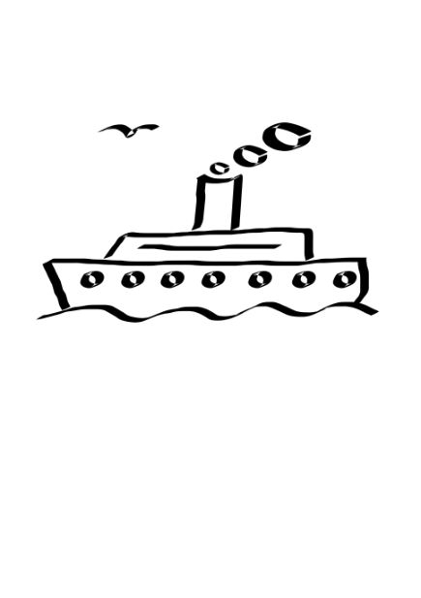

GIFTS FROM ABOVE PRESENTS
“STEPS OF PAUL” CRUISE AND LAND TOUR

OCTOBER 10 – 19, 2024
ON THE CELESTYAL JOURNEY – Celestyal Cruise Line is a multiple time winner of Cruise Critic’s award for Best Dining, Best shore excursions, Best entertainment, Best service AND BEST VALUE!

THE COST FOR OUR PACKAGE
EARLY PURCHASE PRICE PER PERSON: $3998 PER PERSON for deposits received prior to Dec 1, 2023 [Cost is $4298 for deposits made after Dec 1, 2023]
PRICE is further reduced by $75 pp IF THREE SHARE A STATEROOM
AND by $100 pp WHEN 4 SHARE A ROOM

$800 per person deposit made payable to: Gifts From Above, is due with application.
A SECOND INSTALLMENT IN THE AMOUNT OF $800 is due: Jan 1, 2024
Final payments are due: July 1, 2024. (sorry, we do not accept credit cards – payments must be made by check or bank transfer only.)

This 9-NIGHT/10 DAYS round trip cruise and land tour out of (Piraeus) Athens, Greece has been packaged to include the following:
- Round trip air from CHICAGO [other airports available] (*see #1 exceptions below)
- Transfer from Athens airport to hotel.
- One night stay at an Athens hotel in STANDARD ROOM. (**see #2 exceptions below)
- Welcome, reception dinner our first evening in Athens.
- Tour of Acropolis and Mars Hill
- Transportation to cruise ship
- 7 Night accommodations on Celestyal Journey in category IA (***see #3 exceptions below)
- Full board (breakfast, lunch, dinner) – every day while on cruise (****see #4 exceptions below)
- The cruise line’s “PREMIUM, Unlimited Alcoholic & Non-Alcoholic” drink package
(****see #4 exceptions below)
- ONE HOUR FREE WI-FI INCLUDED EVERY DAY.
- Shipboard and Evening entertainment (designed to bring the culture of each port on board)
- Visas for Turkey
- Most tips (*****see #5 exceptions below)
- All port charges and fuel charges (******see #6 exceptions below)
- OUR BIBLE TEACHER WILL BE PASTOR/DR. JEFF HINDS.
- Land Excursions INCLUDED FOR EVERY PORT: (******* see #7 exceptions below)
- Thessaloniki: Full day tour of Thessaloniki and Berroia
- Kavala: Half day tour of Neapolis & Phillipi
- Istanbul: Full day ‘best of the best’ tour of Istanbul
- Dikili: Half day tour of Ancient Pergamon
- Ephesus: Half day tour of Ancient Ephesus & Miletus
- Patmos: Tour of St. John’s Monastery & Grotto of Apocalypse
- Return transportation – cruise ship to airport.

EXCEPTIONS AND EXCLUSIONS:
- Coach Airfare is included in our quote. (Other nationwide departures are available upon request.).
- Price is based upon double occupancy standard hotel room.
The City of Athens imposes a 3 Euro charge per room per night per room for all rooms in all hotels (this tax is only payable in cash – at the time of check-in -- and cannot be paid in advance). [This tax DOES NOT apply to nights spent on the ship].
In the event the tax (or VAT percentage changes) the hotel reserves the right to adjust the above rates accordingly.
- The inclusive price quoted is for CATEGORY IA (inside stateroom on deck 4) Upgrades to XC (exterior room with window on deck 4 or 5 – add $350 pp); SBJ (junior suite with balcony – add $620 pp) or SB – (full suite with balcony – add $1070 pp) may be requested for an additional charge per person.
- A WELCOME DINNER & BREAKFAST IS INCLUDED DURING OUR ONE NIGHT PRE-CRUISE STAY IN ATHENS. LUNCH AND BEVERAGES ARE NOT INCLUDED IN OUR PRICE DURING THE PRE-CRUISE LAND PORTION.
- WHILE ALL TIPS AND GRATUITIES ARE INCLUDED FOR ALL SERVICES ON THE CRUISE SHIP AND AT THE HOTEL -- OUR CLIENTS NEED TO BE AWARE THAT TIPS FOR GUIDES ARE OPTIONAL & ARE ENTIRELY AT THEIR DISCRETION. (We recommend $4 - $6 for a half day; $6 – 8 for a full day, per person).
- CELESTYAL CRUISE LINE reserves the right to impose fuel charges in the amount of $4 per person per day should the price of ice Brent exceed US $90; and $8 per person per day should the price of ice Brent exceed US $110.
- Please be aware – weather or other circumstances can result in unexpected port changes. The itinerary is subject to changes and revisions.
- Gifts From Above utilizes guest pastors as teachers for our cruise tours. In the rare event an advertised pastor is unable to fulfill his teaching responsibilities, we will engage a replacement.

Benefits of group travel to Steps of Paul sites by ship:
- You will experience the vibrant colors of the Aegean Sea and islands. Renowned not only for intense beauty, but for its historical importance regarding the civilization of Ancient Greece.
- Our extensive panorama of sites and excellent Bible teacher will make God’s Word come alive.
- You unpack and pack only once.
- The official shipboard language is English; there’s always someone on hand to help and give guidance.
- You won’t have to worry about finding good, reasonable restaurants, and you’ll still have the flexibility to dine alone or with friends.
- Breakfast, lunch and dinner are all included (on the days we are on the ship)
- There will be independent time. You’ll have fun exploring, shopping, or relaxing on your own or with your new friends.
- No hidden extras at hotels. You won’t have to deal with the inconvenience and extra expense of handing out tips to porters and chambermaids throughout your stay.
- We will have professional tour directors, licensed guides and professional drivers. You can completely relax, knowing that an experienced escort is taking care of all the details and reconfirming every arrangement for your comfort and enjoyment.
- Travel by cruise ship to all our destinations is safe and secure. Embarkation security is comparable to the high standards of airlines. While many European cities currently have ‘travel advisories’ in effect, there are no longer advisories for Turkey.

OUR 9-NIGHT; 10-DAY ITINERARY
Oct 10 Thurs – depart USA on overnight flight to Athens, Greece
Oct 11 Fri – arrive Athens –– transfer to hotel and check in – enjoy a welcome dinner
Oct 12 Sat – check out of hotel; visit Acropolis and Mars Hill before heading to ship;
Celestyal Journey Departs Piraeus on Saturday, October 12, 2024 at 3 PM
Day | Port | Arrive | Depart
Oct 12 Sat | Piraeus (Greece) | - | 15.00 // 3 PM
Oct 13 Sun | Thessaloniki (Greece | 08.00 | 18.00// 6 PM
Oct 14 Mon | Kavala (Greece) | 08.00 | 16.00// 4 PM
Oct 15 Tues | Istanbul (Turkey) | 09.30 | 20.00// 8 PM
Oct 16 Wed | Dikili (Turkey) | 12.00 | 20.00 // 8 PM
Oct 17 Thurs | Kusadasi (Turkey) | 08.00 | 23.30 // 11:30 PM
Oct 18 Fri | Patmos (Greece) | 07.00 | 18.30 // 6:30 PM
Oct 19 Sat | Piraeus (Greece) | 06.00 | Return to Athens airport for flight home
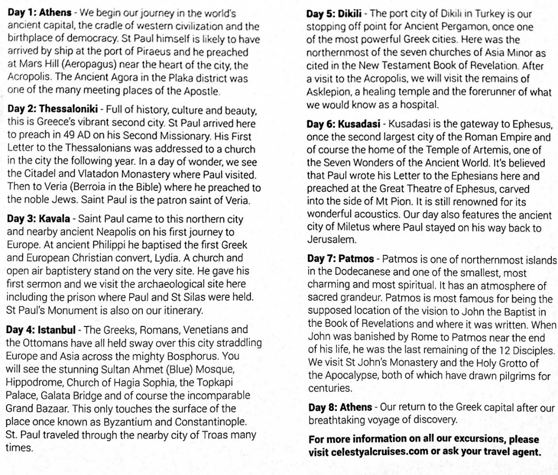

OUR REFUND POLICY – PLEASE NOTE: Travel insurance is highly recommended.
Gifts From Above will issue a full refund of all deposits within a 30-day period of application. Due to supplier regulations, a $350 administrative fee will be deducted from all refunds requested after 30 days.
Upon receipt of second installment, we will purchase group airline seats. Airline seats are nonrefundable/ nontransferable and are not exchangeable. Once group airline ticketing is completed, cancellations will not receive a refund of the deposit or second installment of total cruise/tour cost.
60 days prior to departure only a 25% refund of the third and final payment will apply.
Cancellations made between 59 and 40 days prior to travel will receive only a 10% refund of the third and final payment.
Cancellations made 39 days or less before travel date are ineligible for any refunds.
– ANY REQUESTS FOR CANCELLATIONS MUST BE MADE IN WRITING TO GIFTS FROM ABOVE. THE POST MARK ON THE ENVELOPE (OR YOUR E-MAIL) WILL SERVE AS DATE OF OFFICIAL NOTICE OF INTENT TO CANCEL.

PLEASE NOTE -- AIRLINE TICKETS AND SEAT ASSIGNMENTS - We negotiate special rates with major carriers and air arrangements are subject to certain restrictions on change/or cancellation, eligibility and seat assignments. Group seating policy is different for each airline. Gifts From Above are not in control of seat assignments. Seats are subject to airline discretion and may change without notice. We do everything possible to confirm seats whenever available. Some airlines and/or fare types do not allow for pre-seating and require this be done at airport check-in only. Even when seats are originally pre-assigned, they are not guaranteed and can be modified by the airline due to equipment changes. Bulkhead and exit row seats cannot be requested or pre-assigned ahead of time. Bulkhead seats are given to the passengers traveling with infants and for those with disability. Exit row seats are held for assignment at airport check in only, as passengers wishing to sit in these seats must be physically capable of carrying out the associated responsibilities. The airline agent must see a passenger’s physical condition before assigning them an exit row seat. On most routes, these seats can be purchased for a fee on arrival at the airport. At the time of booking flights we will update all travelers on seating regulations. Gifts From Above are not responsible for flights that are occasionally overbooked, delayed or cancelled by the airlines. All fares and schedules are subject to change without notice.
RESPONSIBILITY / DISCLAIMER STATEMENT Gifts From Above acts only as an agent for the various independent suppliers that provide hotel accommodations, transportation, sightseeing, activities, or other services connected with this tour. Such services are subject to the terms and conditions of those suppliers. Gifts From Above and their respective employees, agents, representatives, and assigns accept no liability whatsoever for any injury, damage, loss, accident, delay, or any other incident which may be caused by negligence, defect, default of any company or person in performing these services. Responsibility is not accepted for losses, injury, damages or expenses of any kind due to sickness, weather, strikes, hostilities, wars, terrorist acts, acts of nature, local laws or other such causes. All services and accommodations are subject to the laws and regulations of the country in which they are provided. Gifts From Above is not responsible for any baggage or personal effects of any individual participating in the tours / trips arranged by Gifts From Abovel. Individual travelers are responsible for purchasing a travel insurance policy, if desired, that will cover some of the expenses associated with the loss of luggage or personal effects.
PHOTO/VIDEO RELEASE - I hereby consent to and authorize the use and reproduction by Gifts From Above of any and all photography and/or videography that has been taken of me this trip for any purpose, without compensation to me. All digital image and/or video files are wholly owned by Gifts From Above, who reserves the right to use these images and/or video for publication on their website, Facebook page, and/or LinkedIn.
ROBERTA KLEIN
GIFTS FROM ABOVE
1535 MEMORIAL HWY
SHAVERTOWN, PA 18708
Phone : 570.575.1710 // Web site : giftsfromabove.info // E-mail: ark2@epix.net
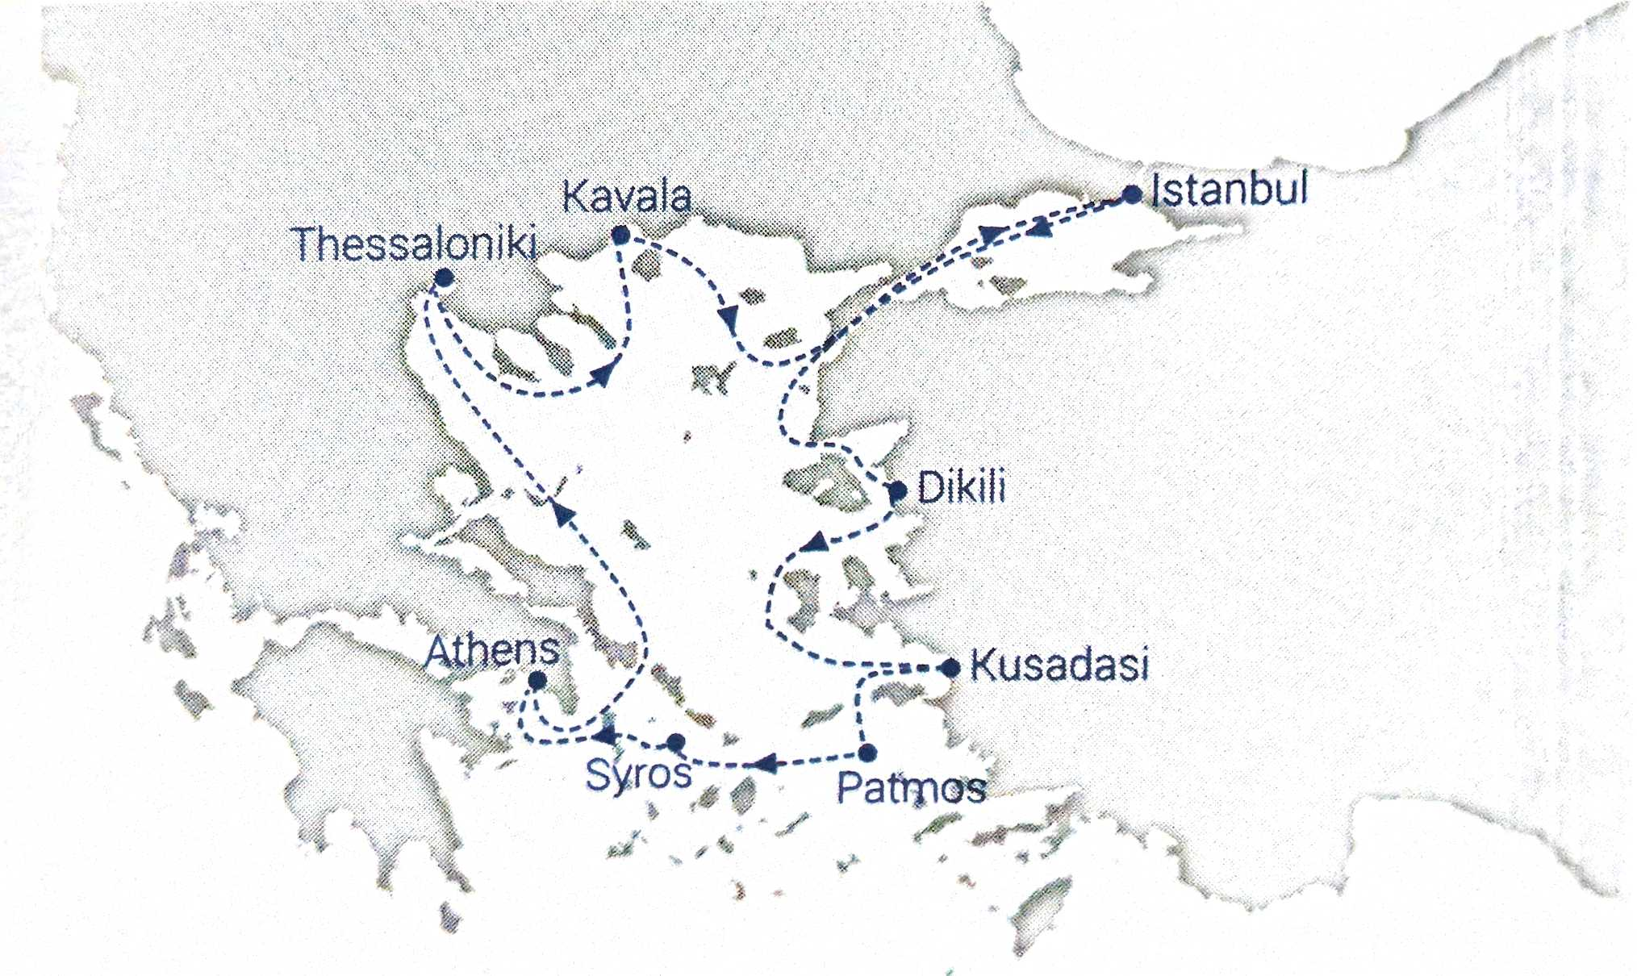

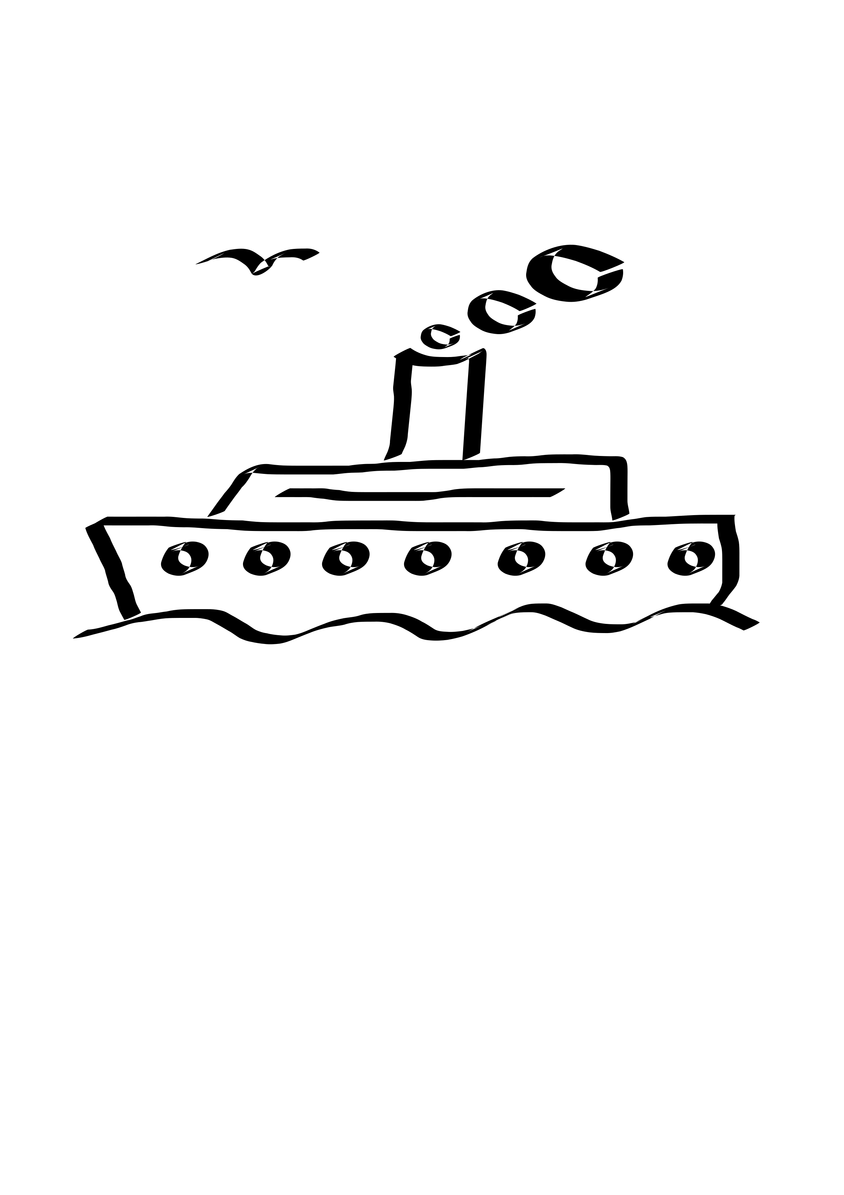

APPLICATION – Page 1 of 2 (each page must be submitted in entirety)
(Please make a copy for your records and use one application per person)
“STEPS OF PAUL” CRUISE AND LAND TOUR WITH PASTOR JEFF HINDS
OCTOBER 10– 19, 2024

PRICE PER PERSON: $3998 PER PERSON for deposits received prior to Dec 1, 2023 [Cost is $4298 for deposits made after Dec 1, 2023]
PRICE is further reduced by $75 pp IF THREE SHARE A STATEROOM
AND by $100 pp WHEN 4 SHARE A ROOM
$800 per person deposit made payable to: Gifts From Above, is due with application.
A SECOND INSTALLMENT IN THE AMOUNT OF $800 is due: Jan 1, 2024
Final payments are due: July 1, 2024. (sorry, we do not accept credit cards – payments must be made by check or bank transfer only.)

YOUR FULL NAME: _________________________________________________________________________
(PRINTED exactly as it appears on your passport)
YOUR DATE OF BIRTH:_____________ GENDER:____ YOUR PASSPORT #:______________________
(Please make a photocopy of the photo page of your passport and submit it along with this application. If you do not yet have a passport, please note that and send a photocopy of your driver’s license.)
OUR REFUND POLICY – PLEASE NOTE: Travel insurance is highly recommended.
Gifts From Above will issue a full refund of all deposits within a 30 day period of application. Due to supplier regulations, a $350 administrative fee will be deducted from all refunds requested after 30 days.
Upon receipt of second installment, we will purchase group airline seats. Airline seats are nonrefundable/ nontransferable and are not exchangeable. Once group airline ticketing is completed, cancellations will not receive a refund of the deposit or second installment of total cruise/tour cost.
60 days prior to departure only a 25% refund of the third and final payment will apply.
Cancellations made between 59 and 40 days prior to travel will receive only a 10% refund of the third and final payment.
Cancellations made 39 days or less before travel date are ineligible for any refunds.
– ANY REQUESTS FOR CANCELLATIONS MUST BE MADE IN WRITING TO GIFTS FROM ABOVE. THE POST MARK ON THE ENVELOPE (OR YOUR E-MAIL) WILL SERVE AS DATE OF OFFICIAL NOTICE OF INTENT TO CANCEL.

PLEASE NOTE -- AIRLINE TICKETS AND SEAT ASSIGNMENTS - We negotiate special rates with major carriers and air arrangements are subject to certain restrictions on change/or cancellation, eligibility and seat assignments. Group seating policy is different for each airline. Gifts From Above are not in control of seat assignments. Seats are subject to airline discretion and may change without notice. We do everything possible to confirm seats whenever available. Some airlines and/or fare types do not allow for pre-seating and require this be done at airport check-in only. Even when seats are originally pre-assigned, they are not guaranteed and can be modified by the airline due to equipment changes. Bulkhead and exit row seats cannot be requested or pre-assigned ahead of time. Bulkhead seats are given to the passengers traveling with infants and for those with disability. Exit row seats are held for assignment at airport check in only, as passengers wishing to sit in these seats must be physically capable of carrying out the associated responsibilities. The airline agent must see a passenger’s physical condition before assigning them an exit row seat. On most routes, these seats can be purchased for a fee on arrival at the airport. At the time of booking flights, we will update all travelers on seating regulations. SHOULD A SPECIAL AIRLINE SEAT BE REQUIRED, WE WILL GIVE AN OPTION TO PURCHASE AN UPGRADE AT THE TIME OUR AIRLINE CARRIER IS SELECTED. Gifts From Above are not responsible for flights that are occasionally overbooked, delayed or cancelled by the airlines. All fares and schedules are subject to change without notice.
PLEASE NOTE – RESPONSIBILITY / DISCLAIMER STATEMENT Gifts From Above acts only as an agent for the various independent suppliers that provide hotel accommodations, transportation, sightseeing, activities, or other services connected with this tour. Such services are subject to the terms and conditions of those suppliers. Gifts From Above and their respective employees, agents, representatives, and assigns accept no liability whatsoever for any injury, damage, loss, accident, delay, or any other incident which may be caused by negligence, defect, default of any company or person in performing these services. Responsibility is not accepted for losses, injury, damages or expenses of any kind due to sickness, weather, strikes, hostilities, wars, terrorist acts, acts of nature, local laws or other such causes. All services and accommodations are subject to the laws and regulations of the country in which they are provided. Gifts From Above is not responsible for any baggage or personal effects of any individual participating in the tours / trips arranged by Gifts From Above. Individual travelers are responsible for purchasing a travel insurance policy, if desired, that will cover some of the expenses associated with the loss of luggage or personal effects.
PHOTO/VIDEO RELEASE - I hereby consent to and authorize the use and reproduction by Gifts From Above of any and all photography and/or videography that has been taken of me this trip for any purpose, without compensation to me. All digital image and/or video files are wholly owned by Gifts From Above, who reserves the right to use these images and/or video for publication on their website, Facebook page, and/or LinkedIn.
APPLICATION – page 2 of 2 (each page must be submitted in entirety)
(please make a copy for your records and use one application per person)
Kindly mail all applications, payments and/or cancellation notices to:

ROBERTA KLEIN
GIFTS FROM ABOVE
1535 MEMORIAL HWY
SHAVERTOWN, PA 18708
Phone : 570.575.1710 // Web site : giftsfromabove.info // E-mail: ark2@epix.net

YOUR STREET ADDRESS:____________________________________________________________________
CITY & STATE:_______________________________ ZIPCODE:____________
MOBILE/CELL PHONE:_________________________ E-mail:__________________________________________
NAME AND ADDRESS OF EMERGENCY CONTACT PERSON:
_________________________________________________________________________________
PHONE#__________________ RELATIONSHIP:___________________________________
YOUR PERSONAL PHONE OR EMERGENCY CONTACT E-MAIL WHILE ON-TOUR:
_____________________________________________________________________________________
HOTEL AND CRUISE SHIP STATEROOM ACCOMODATIONS:
* Please book me in a Category IA Inside stateroom; deck 4 (no extra charge):_______
* I would like to upgrade to Category XC; stateroom with window; deck 4 or 5; added cost $ 360 pp: _______
* I prefer a SBJ; junior suite with balcony – add $620 pp______ or a SB; suite w balcony – add $1070 pp ______
* I will be rooming with:___________________________________
* Will you need a roommate? Yes____ No_____ (if none is available you will need a single room.)
* I prefer a single room:________ (Add $950.00)

PLEASE NOTE – WE WILL WORK TO MATCH ROOMMATES FOR THOSE WHO REQUEST US TO DO SO; HOWEVER, GIFTS FROM ABOVE WILL NOT BE RESPONSIBLE FOR ANY PROBLEMS OR ADDED COSTS WHICH RESULT FROM ROOMMATES PROVING INCOMPATIBLE. SHOULD A PRIVATE STATEROOM BE NECESSARY, THE COST WILL BE THE INDIVIDUAL’S RESPONSIBILITY. (Please carefully check your travel insurance policy at the time of purchase for coverage in that regard).
FLIGHT & GENERAL INFORMATION: Will this be your first trip to the Aegean? Yes____ No ____
Do you require a special diet/meal for your flight or cruise? Yes____ No____
If so, what type of diet?__________________________________________________
Do you have any special travel needs or handicaps?__________________________________
If so, will you require a special seat assignment for your flight?__________________________
(Please note: If a special seat is required, after airline bookings become available, we will give an option to upgrade).

