THE CARIBBEAN IS THE WORLD'S NUMBER ONE CRUISE VACATION DESTINATION!

And no wonder – it provides a fun-filled, year-round playground with something for everyone. No matter what your age or interest, experiencing the Caribbean's delights from a cruise ship adds to the overall experience because of the endless amenities that are included as standards.

There is so much to do on a cruise ship and during a Caribbean Island adventure that it's impossible to list everything offered – and that's where a seasoned travel consultant is best put to use. We can help you match your interests and budget with the ship's amenities and the right itinerary for your group or family. But for starters -- picture your loved ones' faces when docking at multiple beautiful islands with tropical beaches and crystal-clear azure waters. For the venturesome, the islands provide the backdrop for every conceivable action-filled water sport and the chance to experience natural at its best. For others, there's ample opportunity for R & R and a good tan or they can soak up island culture, shop for handmade items in colorful plazas or delve into island history.

Because the Caribbean's such a popular destination, multiple cruise lines devote their best liners to the islands, thus offering countless itineraries (all of which are designed to allow samplings of different regions). This in turn, forces suppliers to compete for business – thus ensuring the prices remain reasonable (generally cruises to the Caribbean cost a fraction of a Mediterranean cruise of the same length).
There are so many fun itineraries to choose from they can make your head spin, but for the most part they are divided up as follows: Eastern Caribbean, Western Caribbean, Southern Caribbean, the Bahamas or even lovely Bermuda (which gets included among the Caribbean itineraries even though, technically, it's in the Atlantic).
While it's true that the majority of Caribbean cruises depart out of Florida – and therefore require air purchase -- during the summer months, there are also options for departures from Boston; New York; Bayonne, New Jersey and Baltimore. Galveston and New Orleans also offer departures and for the Southern Caribbean – San Juan as well as Florida ports are used.
Cruise lengths of 3 – 7 nights are the most popular; but usually you will visit more islands and get the greatest value from a 7-night itinerary.

In my next post, I'll begin a review of the different itineraries – East, West and South – and give more details about the great activities you can look forward to.

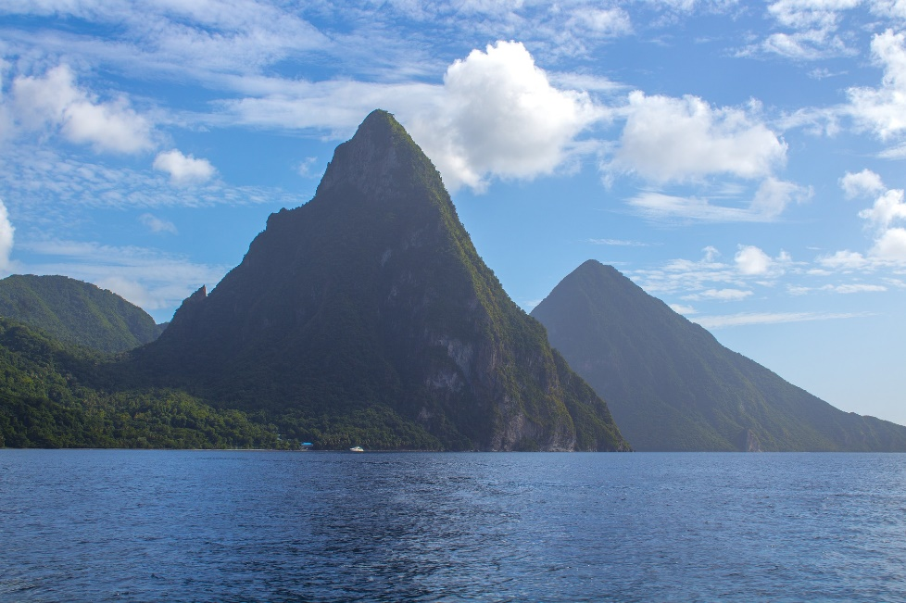
Examples of What Royal Caribbean Offers

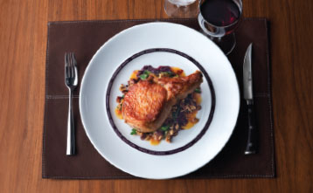
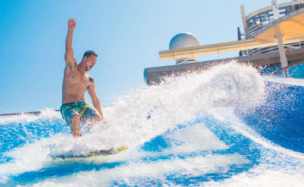
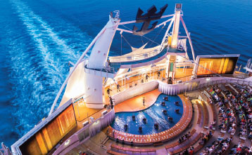
MEALS, BEVERAGES & ROOM SERVICE
SIGNATURE
ACTIVITIES
ENTERTAINMENT & NIGHTLIFE
- Main dining room with savory multicourse feasts each night
- Breakfast, lunch, dinner and snacks in various venues throughout each ship
- Windjammer casual buffet on every ship, open for every meal
- Variety of juices, teas, coffees, soft drinks and water throughout the ship and with meals
- FlowRider® surf simulator — Catch a never-ending swell high above the sea on this thrilling water attraction
- Rock Climbing Wall
- Quantum Class: RipCord® by iFLY® skydiving simulator, North Star observation capsule and SeaPlex play space with bumper cars, roller skating, trapeze school, video games and more
- Oasis Class: Zip Line nine stories above the Boardwalk neighborhood
- Thrilling multi-level waterslides and slides on select ships
- Hit Broadway shows and musical productions, including Grease, CATS, Mamma Mia!, We Will Rock You and Saturday Night Fever
- Live music and comedy shows
- Aqua shows and ice-skating shows
- Parades and parties on the Royal Promenade
- Comedy and live jazz club
- Nightclubs, karaoke and sing-along piano bars
- Lounge games and contests, such as trivia, Puzzle Break, Battle of the Sexes and more
*Specialty dining venues vary by ship. A cover charge or a la carte pricing apply to specialty dining options. *Shrek, Madagascar, Kung Fu Panda, How to Train Your Dragon, Turbo and all related characters and properties TM & ©2016 DreamWorks Animation L.L.C. Features vary by ship.
©2016 Royal Caribbean Cruises Ltd. Ships' registry: The Bahamas. All rights reserved. • 16051283

